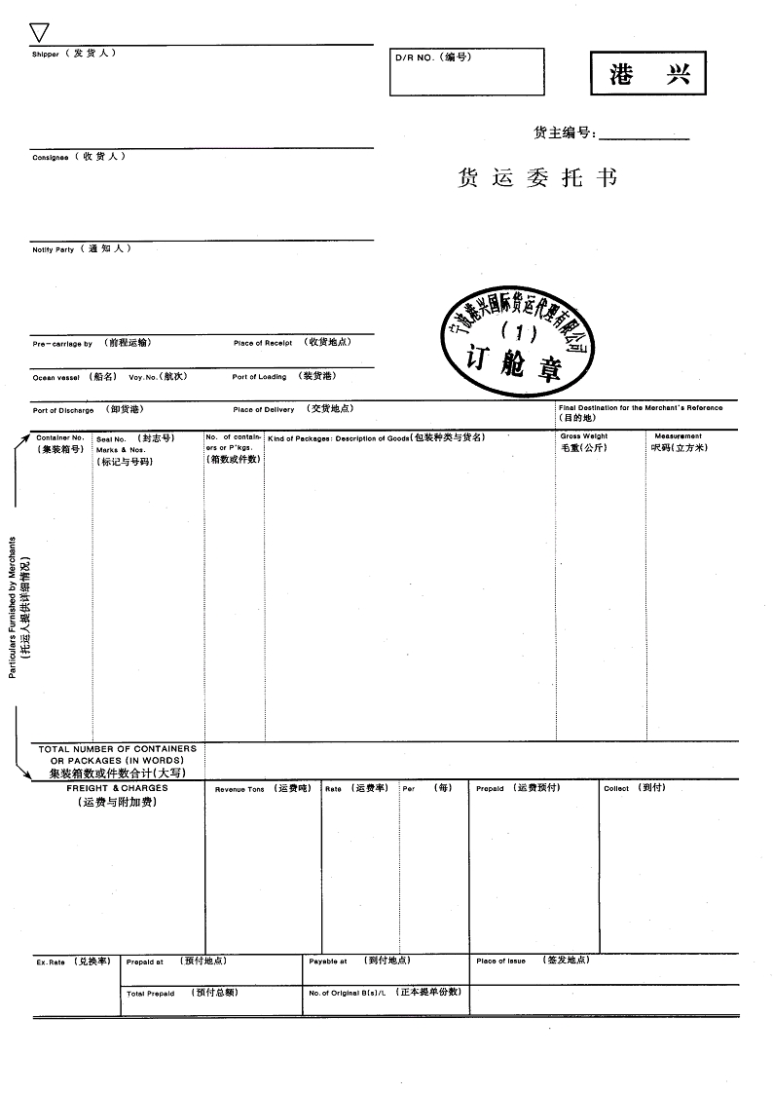

PORTEVER SHIPPING LTD.
TEL ：
FM：
宁波港兴国际货运代理有限公司
配
FAX：
GOTHENBURG
SHANGHAI
COSCO
SAME AS CONSIGNEE

N/M
SHANGHAI
KEY LOGISTICS AB
BOX 7076
402 32 GOTHENBURG
PHONE:+4631 704 14 36 TEL:31-10-2831919 FAX:31-10-2831910
PORTEVER SHIPPING (SHANGHAI) LTD.
1008C SENLING TOWER NO.469 WUSONG RD,
SHANGHAI,CHINA
TEL:63094080 FAX:63094099
KGS
FREIGHT COLLECT
63092820
GOTHENBURG
63244324
CBM
OCT 01,2017
CONSOLIDATED CARGO
COSCO

订AEU5 - EVER GRADE 1218-016W

1*40HQ
预付舱位

200PACKAGES
SAY TWO HUNDRED PACKAGES ONLY
CY-CY
THREE
EUM17090093

